

College of Information and Computing Sciences



Laundry Management System
Software Requirement Specification

Information Technology Project 2025

Submitted by:

JHON LESTER TADILI
JHAKIE REAL
VANESS ROSARIO
JHOANA MAE CORNEJO

Submitted to:

ALBERT ABINAN CANLAS

Date of submission
AUGUST 2022
Table of Contents
Table of Contents ii
Revision History ii
1. Introduction 1
1.1 Purpose 1
1.2 Scope 2
1.3 Definitions, Acronyms, and Abbreviations...............................................................................2-3
1.4 References 3
1.5 Overview 3-4
2. Functional Data Description 4
2.1 Data Overview 4
2.2 Data Structures 5
2.3 Data Flow 6-7
2.4 Data Storage 7
3. Subsystem Description............................................................................................................8
3.1 Subsystem Overview 8
3.2 Subsystem 1: 8
3.3 Subsystem 2: 8
3.4 Subsystem 3: 9
3.5 Subsystem 4: 9
4. System Modeling and Simulation Results..........................................................................10
4.1 System Model: 10
4.2 Simulation Results 11
5. Products................................................................................................................................11
5.2 Product Overview 11
5.3 Product 1: 11
5.4 Product 2: 12
5.5 Product 3: 12
5.6 Product 4: 12-13
6. Appendices 13
Appendix A: Glossary 13
Appendix B: References.............................................................................................................13
Appendix C: Change Log............................................................................................................13

Revision History
Name | Date | Reason For Changes | Version

Introduction

Purpose

The goal of this Software Requirements Specification (SRS) is to present a clear, comprehensive, and unified understanding of what the Laundry Management System (LMS) is intended to accomplish. Rather than being just a list of technical points, this document acts as a bridge between the people who will use the system and the team responsible for developing it.
This document is intended for software developers, project consultants, managers, and all stakeholders involved in the design, development, and implementation of the LMS. For developers, it serves as a detailed technical road-map, outlining exactly what needs to be built. For managers and consultants, it provides a structured framework to monitor progress, make informed decisions, and ensure that each feature supports the business objectives.
The LMS is built with a single purpose: to make running laundry operations simpler, faster, and more precise. From receiving customer orders to processing payments, and from tracking services to generating reports, it aims to streamline daily tasks, minimize mistakes, and save valuable time. By automating repetitive processes, the system allows laundry shop owners and employees to concentrate more on delivering excellent customer service rather than spending time on manual paperwork.
Ultimately, this document ensures that everyone whether they have a technical background or not has a clear picture of the system’s functions, operations, and benefits. It also serves as an official agreement between stakeholders and the development team, ensuring that the final product aligns with the original vision and meets user needs.

1.2 SCOPE
The Laundry Management System (LMS) is a desktop-based application designed to assist laundry service providers in managing their day-to-day operations efficiently. This system aims to replace manual record-keeping processes with a digital solution that is more accurate, faster, and easier to use.
The LMS will allow authorized users to perform tasks such as managing customer information, handling laundry orders, tracking payments, and monitoring the status of services. It will be developed with a user-friendly graphical interface, making it accessible even to users with minimal technical experience.
The system will support multiple user roles with varying levels of access to ensure data security and proper workflow management. It will be used primarily by laundry shop staff and administrators in a local network environment, with the potential for future expansion to online or mobile platforms.
This SRS document covers the requirements for the initial version of the Laundry Management System. It does not include features such as online booking, mobile app integration, or third-party payment gateway support, which may be considered for future enhancements.

1.3 Definitions, Acronyms, and Abbreviations
LMS – Laundry Management System
SRS – Software Requirements Specification
GUI – Graphical User Interface
Admin – A user with full system control and access privileges
User – Any person who uses the system (admin, staff, manager)
Customer – A person receiving laundry services
Order – A transaction that includes items submitted for laundry services
Service – A type of laundry work (e.g., wash, dry clean, iron)
Status – The current state of an order (e.g., Pending, In-Progress, Completed)
Payment Status – Indicates whether an order is paid, unpaid, or partially paid
Item – Clothing or materials submitted by a customer for service
Inventory – Supplies and materials used in laundry operations
Role – The access level assigned to a user (e.g., Admin, Staff)
Database – A structured collection of data used to store system records

1.4 References
IEEE 830-1998 – IEEE Recommended Practice for Software Requirements Specifications.
830-1998 - IEEE Recommended Practice for Software ...

Laundry Business Process Documentation – Internal document outlining standard laundry shop workflows and procedures.
Business Processes Laundry | Clothing

User Interface Design Guidelines – General best practices for creating user-friendly and accessible software interfaces.
User Interface Design Guidelines

Software Engineering: A Practitioner’s Approach by Roger S. Pressman – Reference material for structuring software documentation and development methodologies.
Software Engineering: A Practitioner's Approach

Design and implementation of a Laundry Management

Design and Implementation of a Laundry Management ...

1.5 Overview
While the Software Requirements Specification (SRS) document is generally intended for a broad audience, this particular document is designed for individuals directly involved in the development and implementation of the Laundry Management System (LMS). This includes software developers, system designers, project consultants, and team managers.
The document provides a detailed breakdown of the system’s core components, data handling, subsystems, and models. It does not require sequential reading users are encouraged to refer directly to the sections most relevant to their role or task.

A brief outline of the document is as follows:
Functional Data Description
Subsystem Description
System Modeling and Simulation Results
Products
Appendices

Functional Data Description

2.1 Data Overview
The Laundry Management System (LMS) will handle important types of information that help keep the daily operations of the laundry shop running smoothly. These include details:
User Information – Details of system users such as administrators and staff, including usernames, roles, and login credentials.
Customer Records – Information about each customer, including their name, contact details, and service history.
Laundry Orders – Every transaction made, including items dropped off, selected services (e.g., washing, ironing), order dates, and payment details.
Service Catalog – A list of available laundry services with descriptions and prices.
Inventory Items (optional) – Items like detergents or packaging materials used in operations.

2.2 Data Structures
- Admin
- Can log in to the system.
- Can delete or edit customer and order records.
- Maintains the database of all laundry transactions and registered users.
- Can update service types, pricing, and system settings
- Can view, print, and export reports (sales, customer activity, payment summaries).

- Customer / User
- Can create an account.
- Can log in to the system.
- Can view available laundry services and pricing.
- Can place a laundry order by specifying service details (e.g., wash, dry clean, pressing).
- Can track the status of their laundry (e.g., pending, in process, completed).
- Can update personal account information.
- Can cancel an order before processing starts.
- Can view their order history.
- Can give feedback or rate the laundry service (only after order completion).

- Laundry Staff
- Can log in to the system.
- Can view assigned orders.
- Can update order status (e.g., received, washing, drying, ready for pickup).
- Can process payments and mark payment status as paid/unpaid.
- Can add service details to orders.
- Can view daily/weekly schedules for laundry processing.

2.3 Data Flow
- Covers what data is entered into the system (input)
- Explains how the system handles and processes that information (processing)
- Describes what comes out as a result (output)
- Data Flow Diagram (DFD) to show the step-by-step path of the data in a clear, visual way

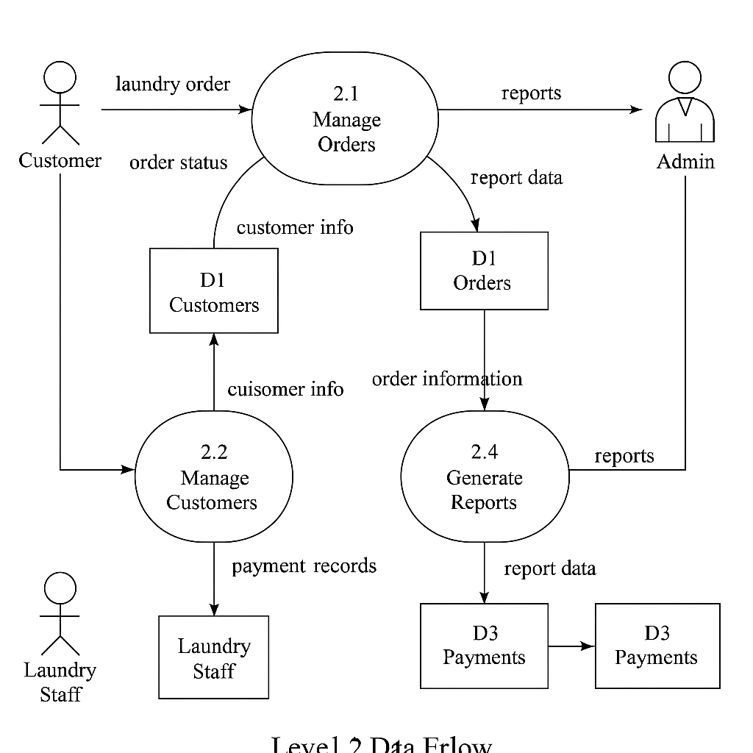

DFD shows in detail how the Laundry Management System works:
- Customer Management – Stores and updates customer information so it’s easy to find when making orders.
- Order Processing – Records laundry orders, calculates costs, and keeps them linked to the right customer
- Payment Processing – Handles customer payments and updates the order status once paid.
- Service Tracking – Updates the status of each laundry order, like “Washing” or “Ready for Pickup,” so customers know the progress.
- User Login – Checks usernames and passwords to make sure only authorized users can access the system.
- Reports – Prepares summaries of sales, orders, or customers for the admin to review.

2.4 DATA STORAGE
All data will be stored in a relational database (e.g., MySQL or SQLite), installed locally on the machine running the system. The system will support basic data operations such as:
- Creating records – Adding new users, customers, or orders
- Reading records – Viewing service history or current orders
- Updating records – Changing order status or updating customer contact information
- Deleting records – Removing outdated or cancelled entries

Subsystem Description

3.1 Subsystem Overview

The system is made up of several subsystems, each handling a specific task, like managing customers, tracking orders, or handling payments. All these subsystems are connected and work together to make laundry service smooth and organized.

3.2 Subsystem 1: Customer Management

This part keeps track of customer information. It stores names, contact details,service preferences, and past orders. Whether it’s a returning customer or a first-timer, this subsystem helps the business know who the customer is and what they need.

Function 1 | Add Customer
Input | Member code, Phone number, Company, Name, E-mail, Gender, Address
Output | Database Record, Database successfully updated message
Processing | Validate the given details and record the information in to the database.

3.3 Subsystem 2: Order Management
Here’s where every laundry order is recorded and tracked from the moment clothes are dropped off until they’re ready for pickup. It helps staff manage what service each order needs and keeps everything organized.
 | Add Order
Input | Order ID, Customer Name, Contact Number, Service Type, Quantity/Weight, Price, Order Date, Pickup/Delivery Date, Payment Status
Output | Database Record, Order successfully created message
Processing | Validate the given details and record the information in to the database.

3.4 Subsystem 3: Payment Processing
This handles all payments. Whether the customer pays in cash, by card, or via mobile, this subsystem makes sure the payment is recorded properly and a receipt is given. It also keeps a record of all transactions for easy tracking.
 | Add Payments
Input | Total, pay time, Credit card details, online payments
Output | Database Record, Database successfully updated message
Processing | Validate the given details and record the information in to the database.

3.5 Subsystem 4: Notifications and Order Status
This part lets customers know what's happening with their laundry. It can send updates like "Your laundry is ready for pickup!" via text or email. It helps keep customers informed without them having to ask.
 | Order Status
Input | Order ID, New Status (e.g., Pending, In Progress, Completed, Delivered)
Output | Order status updated message
Processing | Locate the order in the database, update its status, and store the changes

System Modeling and Simulation Results

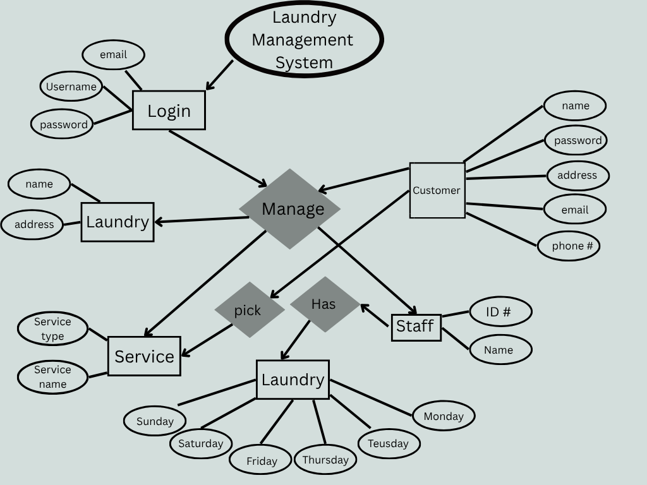
4.1 System Model
To clearly understand how the Laundry Management System works, several models are created—such as the Entity-Relationship Diagram (ERD), which shows how data is stored and connected, and the use case diagram, which illustrates how different users (like admin, staff, and customers) interact with the system. These visual tools make it easier for both developers and non-technical users to see the overall flow of operations, from receiving customer orders to processing and delivering laundry services.
4.2 Simulation Results
After building and testing the Laundry Management System, we carefully reviewed how well it meets the needs of both the business and its customers. This evaluation looked at ease of use, accuracy of information, speed of processing orders, and how reliable the system is during peak hours. Feedback from test users—such as staff and selected customers—was also gathered to understand their experience. Based on the results, adjustments were made to improve features, fix minor issues, and make the system more user-friendly. The goal is to ensure that the final version is efficient, reliable, and ready for real-world use.

PRODUCTS

Product Overview
The Laundry Management System project will produce several essential deliverables aimed at streamlining and automating laundry shop operations. These will consist of the core software application, an integrated database, supplementary modules, and comprehensive documentation to support both implementation and ongoing maintenance.

5.2 Product 1:Core Laundry Management Software
The central application that manages customer records, service selection, order tracking, and payment processing.
Purpose: Streamlines laundry transactions from registration to payment.
Specifications:Web-based platform with an intuitive interface
Integrated with a MySQL database for storing and retrieving records
Accessible for both staff and customers
Dependencies: Requires PHP, MySQL, and a compatible web browser.

Product 2: Database

A MySQL-based database containing structured records for customers, services, orders, and staff.
Purpose: Provides secure, organized, and reliable data storage
Specifications:Relational structure with clearly defined relationships
Designed using an ERD model
Maintains data consistency and integrity
Dependencies: MySQL server and database configuration

5.3 Product 3: Documentation

A complete set of user and technical guides for the Laundry Management System.
Purpose: Ensures proper installation, operation, and troubleshooting of the system.
Specifications:User manual for staff and customers
Technical manual for developers and administrators
Setup and installation instructions
Visual diagrams (DFD, ERD) for reference
Dependencies: None.

5.4 Product 4: Reporting Tool

An internal module that generates operational and sales reports.
Purpose: Provides valuable business insights for better decision-making.
Specifications: Customizable filters by date, service, or staff
Exportable in formats like PDF and Excel
Dependencies: Access to database records and reporting libraries.Appendix A: Glossary

Appendix A: Glossary
Service Type – refers to the kind of laundry service offered, such as wash & fold, dry cleaning, or ironing
Laundry Management System (LMS) – refers to the software used to manage and automate laundry shop operations, such as customer records, orders, and payments..

Appendix B: References
- Microsoft SQL Server Management Studio Express 2010 – User Guide. Microsoft Corporation, 2010.
- Microsoft .NET Framework 4.0 Documentation. Microsoft Corporation, 2010.
- Laundry Shop Management System – Research Articles and Case Studies. Journal of Information Technology and Management, 2022.
- “Best Practices for Database Design.” Oracle Technical White Papers, Oracle Corporation, 2021.
- Windows 10 User Guide and Technical Specifications. Microsoft Corporation, 2015.

Appendix C: Change Log
- Version 1.0 – Initial Release (03/15/2024) – First complete draft of the Laundry Management System SRS created, including functional and non-functional requirements.
- Version 1.1 – Minor Revisions (04/02/2024) – Updated hardware and software requirements; clarified glossary definitions for better understanding.
- Version 1.2 – Feature Enhancement (05/10/2024) – Added support for mobile platforms (Android and iOS) and updated interface design section.
- Version 1.3 – Final Approved Version (06/05/2024) – Incorporated feedback from project stakeholders, finalized documentation, and approved for implementation phase.

